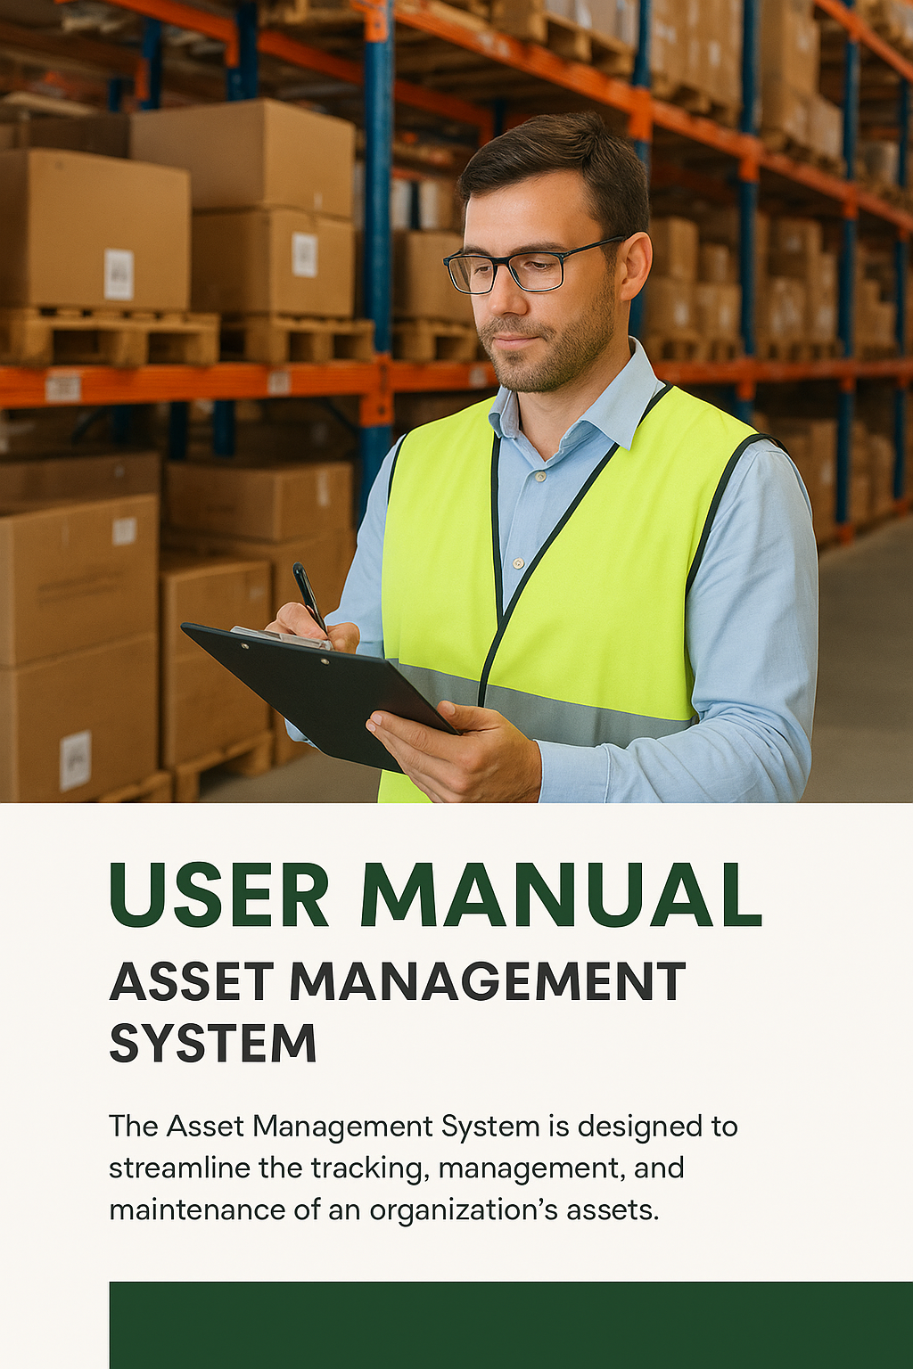

Contents

**1. Introduction** 4

**2. Target Users** 4

**3.1 Common Features for All Users** 5

**3.2 Employee** 7

3.3 Head of Department (HOD) 8

**1. Received Requests** 8

**2. Updated Requests** 9

**3. Raise Request** 10

**4. My Requests** 10

3.4 Store Admin 11

**1. Employee Requests** 11

**2. Issued Employee Requests** 12

**3. HOD Requests** 13

**4. Issued HOD Requests** 13

**5. Issue Report** 14

**6. MRV Report (Material Receipt Voucher)** 15

**7. Master List** 15

**8. Expired List** 16

**9. Stock Alert** 17

4.4 Local Purchase Department Dashboard 17

**4.4.1 Materials List** 17

**4.4.2 Procurement** 18

**4.4.3 Vendor Master** 19

**4.4.4 My Requests** 20

4.5 Central Purchase Department Dashboard 20

**4.5.1 Received Requests** 20

**4.5.2 Vendor Master** 21

**4.5.3 My Requests** 22

4.6 Local Accountant Dashboard 23

**4.6.1 Local Purchased** 23

**4.6.2 Central Purchased** 23

**4.6.3 Budget Management** 24

4.7 Central Accountant Dashboard 25

**4.7.1 PO Details** 25

**4.7.2 Budget Management** 25

4.8 Auditor Dashboard 26

**4.8.1 View Requests** 26

4.9 IUCD Dashboard 27

**4.9.1 View Requests** 27

4. Workflow 28

5. Troubleshooting & Help 29

6. Security & Access Control 29

7. Future Enhancements 29

8. Conclusion 29

**1. Introduction**

The **Asset Management System (AMS)** is designed to streamline and digitize the process of managing assets within an organization. It enables employees and departments to efficiently raise, track, approve, and process material requests while ensuring transparency, accountability, and proper utilization of resources.

This system automates every stage of asset handling — from raising a request to procurement, issuance, and final auditing — providing a seamless workflow across departments.

**Key Objectives:**

* Simplify asset request and approval processes.
* Maintain accurate tracking of issued and available assets.
* Improve coordination between departments.
* Ensure transparency in purchase, budgeting, and audit processes.

**2. Target Users**

The system is role-based, and each user has specific permissions and functionalities according to their responsibilities.

**User Roles:**

* **Employee** – Can raise and track asset requests.
* **Head of Department (HOD)** – Reviews, approves, or rejects requests raised by employees.
* **Store Admin** – Handles request issuance, manages stock, and tracks inventory levels.
* **Local Purchase Department** – Manages procurement, vendor details, and local purchase orders.
* **Central Purchase Department** – Handles centralized procurement and vendor management.
* **Local Accountant** – Manages local purchase budgets and expense tracking.
* **Central Accountant** – Manages budget allocations and central purchase records.
* **Auditor** – Reviews and verifies asset transactions and purchase records.
* **IUCD** – Reviews requests and ensures institutional compliance.

### **3.1 Common Features for All Users**

The Asset Management System provides a consistent interface across all user roles, ensuring easy navigation and accessibility.  
Every authorized user — whether Employee, HOD, Store Admin, or others — will start their interaction with the system through the following core features.

#### **Login Page**

All users begin by logging into the system using their **registered username and password**.  
This ensures that only authenticated personnel can access institutional data.  
Upon successful login, users are automatically redirected to their respective **role-specific dashboards**.

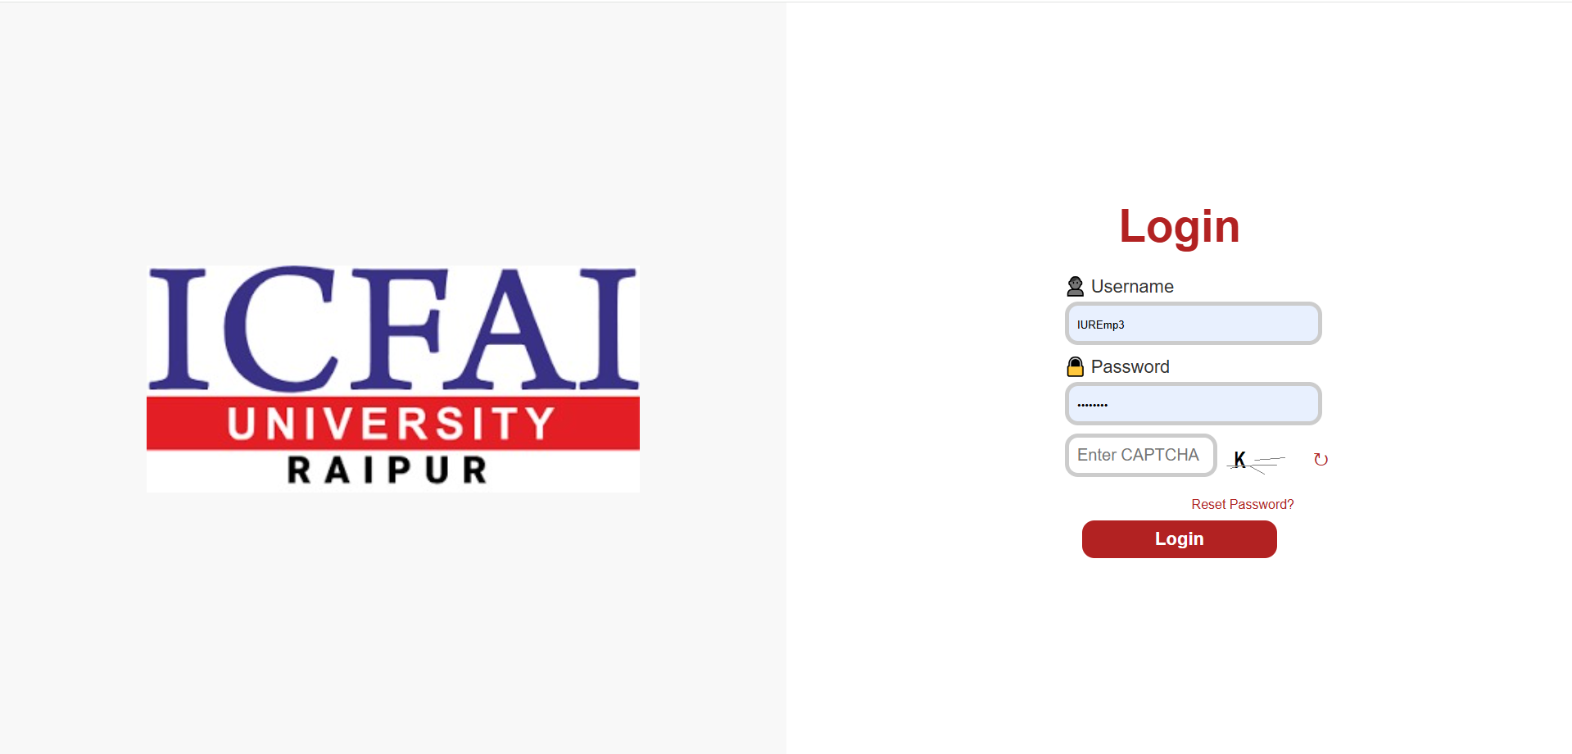

**Key Features:**

* Secure login with username and password.
* Role-based access ensures each user views only relevant data.
* “Forgot Password” option allows recovery through registered email (if configured).

#### **Dashboard**

Once logged in, users land on their **Dashboard**, which provides a **welcome greeting** and a quick overview of their activities.  
This may include pending requests, active transactions, and other relevant summaries depending on the user’s role.

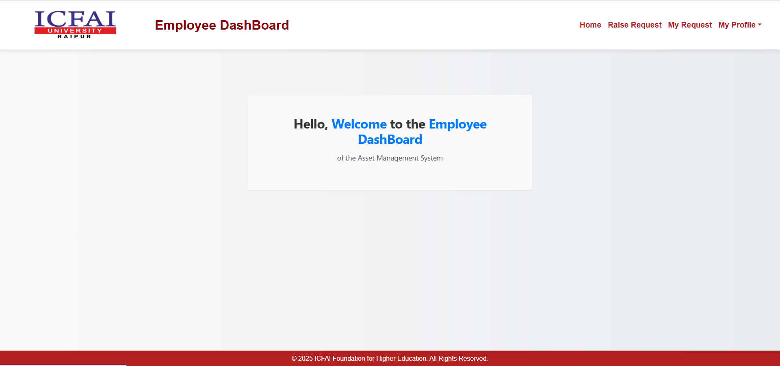

**Highlights:**

* Personalized welcome message with user name.
* Overview of pending or approved requests.
* Quick navigation cards or links to main functions.
* Role-specific insights (e.g., “Requests Pending Approval” for HODs).

#### **Profile Section**

Every user can access the **Profile Section** from the navigation menu.  
This section allows users to **view and update personal details**, such as name, email, and contact number.  
It also provides options to **change the account password** securely.

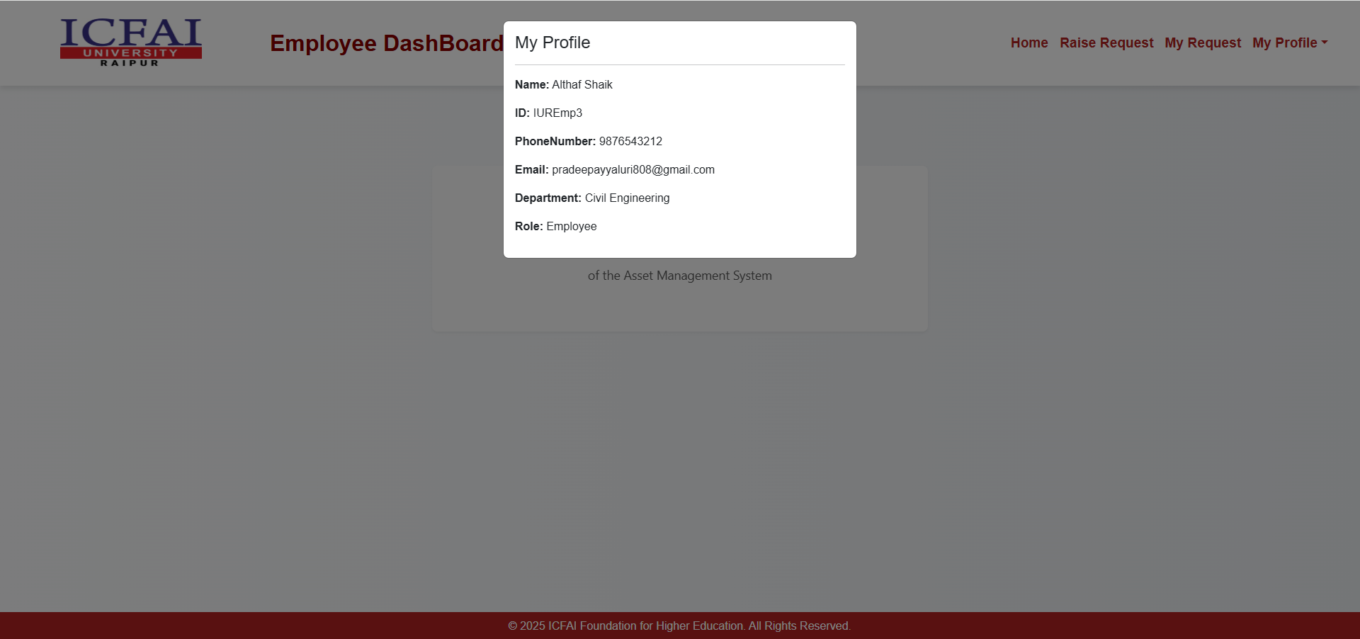

**Features:**

* View and edit personal information.
* Update login credentials (password) securely.
* Ensure profile details remain up-to-date for communication and role mapping.

### **3.2 Employee**

The **Employee Dashboard** is designed for staff members to request materials or assets required for their work and track the progress of these requests.  
It provides a simple interface that ensures quick submission and transparent tracking of all requests.

#### **1. Raise Request**

This section allows employees to create new asset or material requests easily.

**Key Features:**

* Easy selection of materials and categories.
* Auto-recorded request date and employee details.
* Real-time validation to avoid duplicate or invalid entries.
* Instant acknowledgment message after successful submission.

#### 

#### **2. My Requests**

This section displays all requests raised by the employee along with their current status.

**Functions Available:**

* View the **real-time status** of each request.
* Track requests that are approved or awaiting issue.
* Identify rejected requests and understand the reason for rejection.
* Filter or sort requests based on date or status.

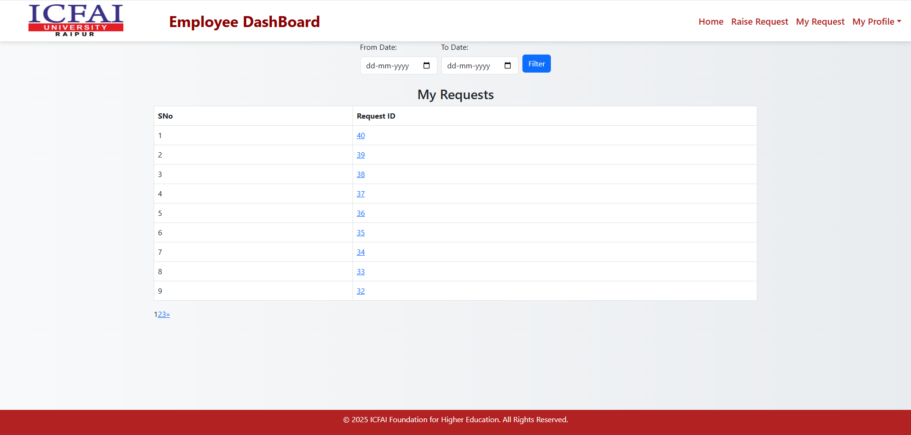

## ****3.3 Head of Department (HOD)****

The **Head of Department (HOD) Dashboard** enables the HOD to review, approve, reject, and manage asset requests made by employees under their department.  
It also allows the HOD to raise new requests on behalf of the department and track their progress efficiently.

The dashboard is structured into four main sections — **Received Requests**, **Updated Requests**, **Raise Request**, and **My Requests** — each designed for specific functions.

### **1. Received Requests**

This section displays **all material or asset requests submitted by employees** within the department awaiting HOD action.

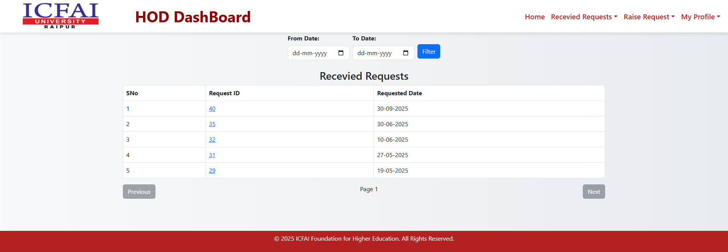

**Key Features:**

* The HOD can take one of two actions:
  + **Approve:** Enter the Approving Quantity and confirm approval.
  + **Reject:** Enter a remark or reason for rejection before submission.
* A **confirmation popup** ensures that accidental approvals/rejections are avoided.
* Once acted upon, requests automatically move to the **Updated Requests** section.

**Tips:**

* Always check previous request history by clicking View Past Requests (if available).
* Use remarks clearly when rejecting a request to maintain proper records.

### **2. Updated Requests**

This view provides a **summary of all requests that have already been processed** by the HOD.  
Requests here are categorized as **Ongoing**, **Approved**, or **Rejected** for better clarity.

**Key Features:**

* Separate tabs or filters for each category:
  + **Ongoing:** Requests under further processing by the Store or Purchase departments.
  + **Approved:** Requests successfully approved and forwarded.
  + **Rejected:** Requests declined by the HOD, along with remarks.
* The HOD can **review past actions** for reference or auditing purposes.

**Benefits:**

* Provides a complete audit trail of departmental decisions.
* Helps avoid duplication and maintains transparency in decision-making.

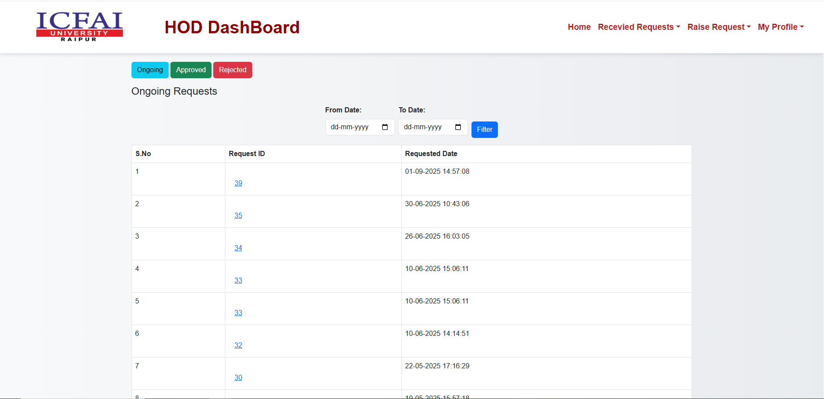

### **3. Raise Request**

The HOD can also initiate new material requests **on behalf of the department** (for shared or lab resources).

**Steps to Raise a Request:**

1. Click on the **“Raise Request”** option in the left menu.
2. Select the **required material** from the dropdown list.
3. Enter the **quantity** needed.
4. Optionally, specify **remarks or justification** for the request.
5. Click **Submit** to forward it to the next level (Store Admin or Purchase Department).

### 

### **4. My Requests**

This section allows the HOD to **track all requests they have personally submitted**, separate from employee-raised ones.

**Features:**

* Monitor request progress in real time.
* View approval and issue history.
* Filter requests by date, material, or status for quick access.
* Option to download or print request summaries for records.

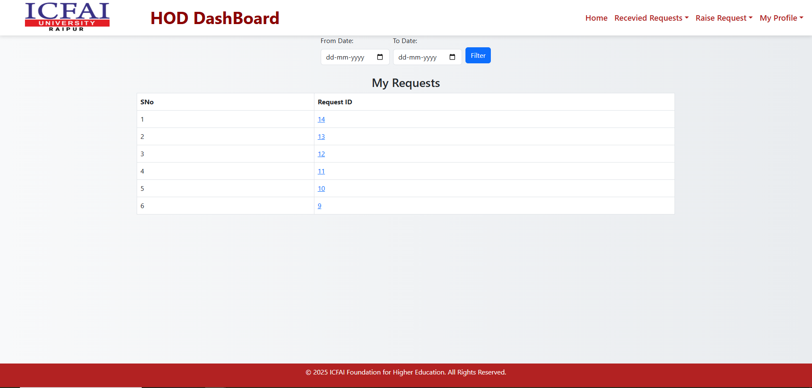

**Tip:**  
Use this section regularly to ensure departmental requests are being processed on time.

## ****3.4 Store Admin****

The **Store Admin Dashboard** serves as the central hub for managing all inventory operations within the institution.  
From processing employee and departmental requests to monitoring stock levels, issuing assets, and generating reports — this module ensures complete control over the asset lifecycle.

The dashboard consists of the following key sections:

### **1. Employee Requests**

This view displays all the **requests raised by employees** and sent through their respective HODs.  
The Store Admin can verify, issue, or reject these requests based on stock availability.

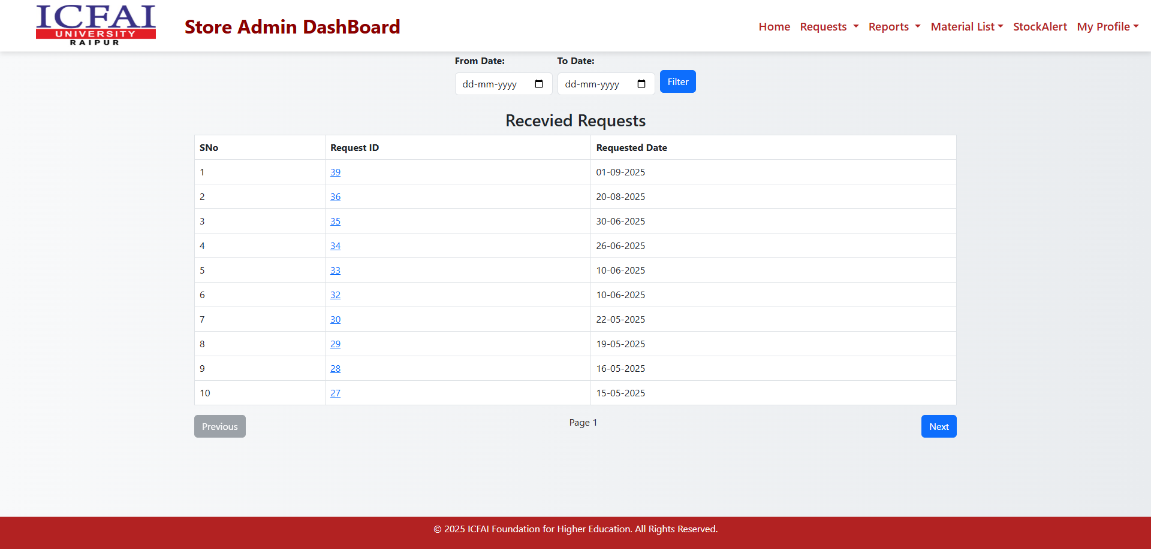

**Key Functions:**

* View detailed list of all pending employee requests.
* Check available stock before approval.
* Approve and issue requested items or reject with proper remarks.
* Update the issued quantity and record issue date.
* Once issued, the request automatically moves to the **Issued Employee Requests** section.

**Tip:** Always ensure the request details and approving quantities are cross-checked before issuing materials.

### **2. Issued Employee Requests**

This section maintains a record of all **materials issued to employees**, ensuring complete traceability.

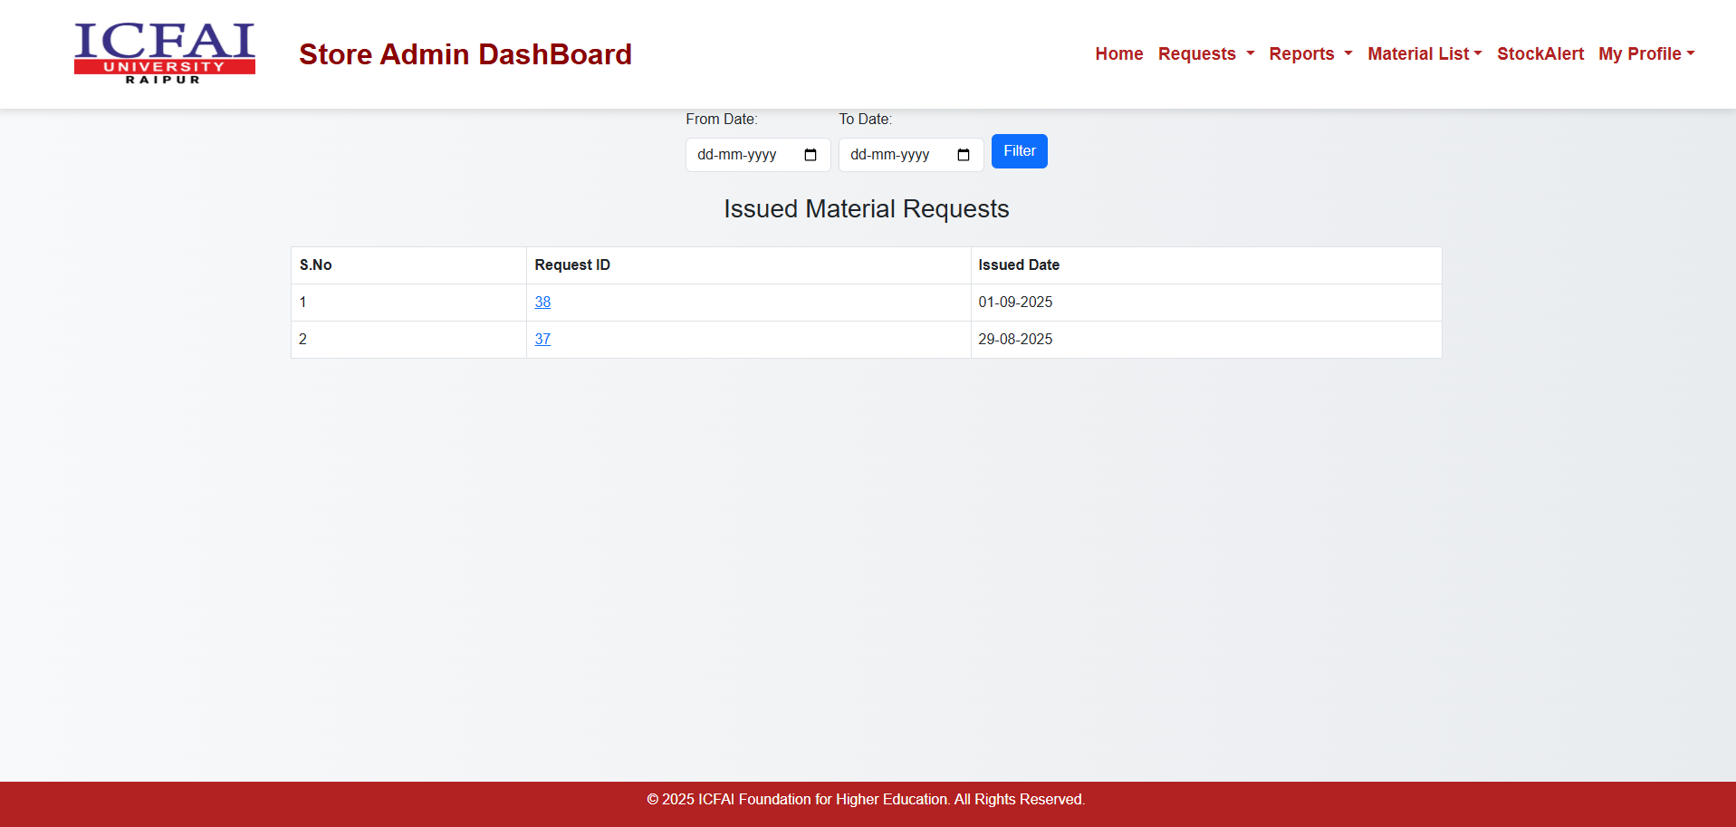

**Features:**

* Displays the list of issued items with:
  + Request ID
  + Employee Name
  + Material Name
  + Quantity Issued
  + Issue Date
  + Return Status
* Enables tracking of materials still in use or pending return.
* Provides export or print options for record-keeping.

**Benefit:** Helps the Store Admin maintain accountability of distributed materials and supports future audits.

### **3. HOD Requests**

This view lists **requests raised by Heads of Departments**, usually for departmental or shared resources.

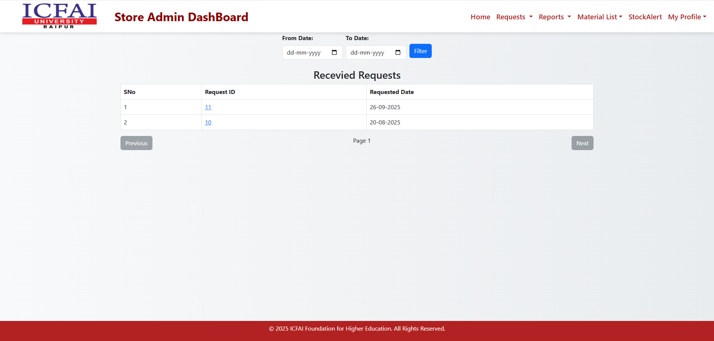

**Key Functions:**

* Displays all HOD-level requests awaiting store action.
* Approve or reject based on stock availability and department priority.
* Record remarks or comments for future reference.
* Forward approved requests for issuance processing.

**Note:** Departmental requests are typically of higher value or quantity; handle them with extra verification.

### **4. Issued HOD Requests**

Once departmental requests are processed, they appear here for tracking and record management.

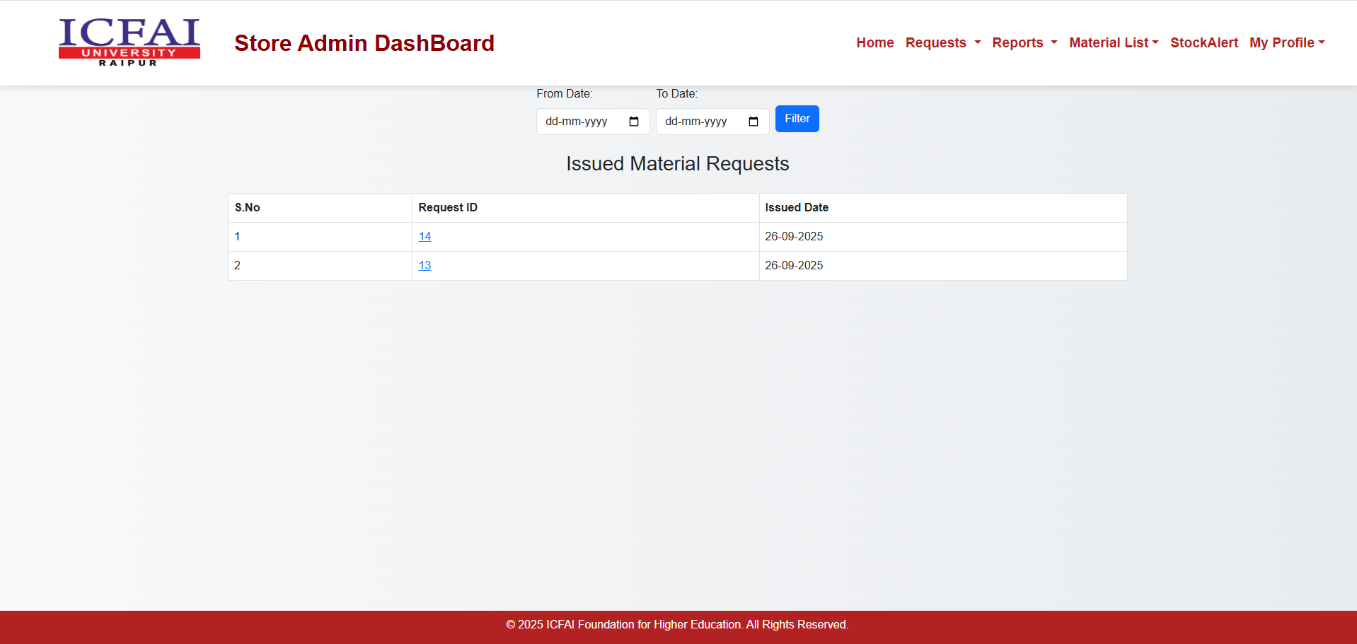

**Features:**

* Displays issued department-level materials along with:
  + Department Name
  + Request ID
  + Material Name
  + Quantity Issued
  + Issue Date
* Allows marking of items returned or replaced when applicable.
* Facilitates accountability for inter-departmental asset usage.

### **5. Issue Report**

The **Issue Report** provides a consolidated view of all materials issued — both to employees and departments.

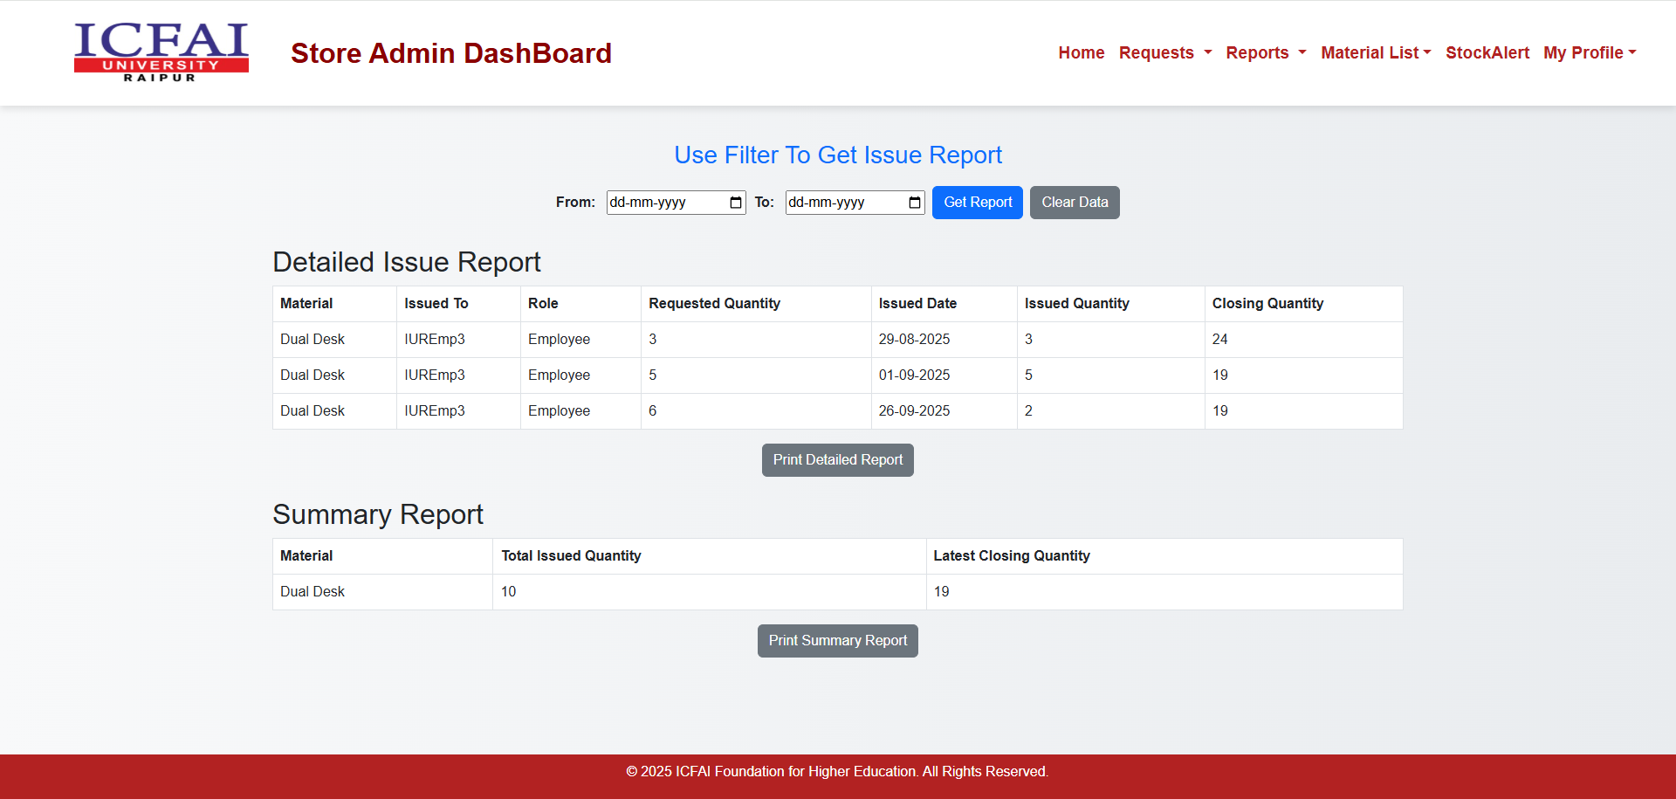

**Highlights:**

* Generate date-wise or category-wise reports of issued items.
* Filter by user, department, or material type.
* Export reports in Excel or PDF format for documentation.
* Useful for monthly summaries and internal audits.

**Tip:** Regularly download and archive reports to maintain a clean issue record.

### **6. MRV Report (Material Receipt Voucher)**

This section manages and stores details of all materials received through purchase or return.

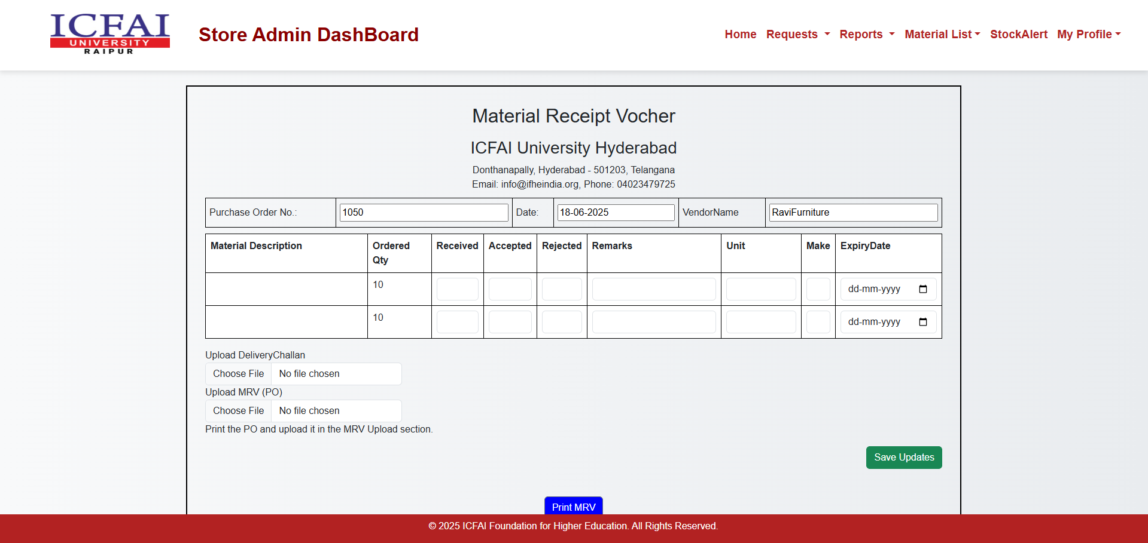

**Functions:**

* Record details like Vendor Name, MRV Number, Received Date, and Quantity.
* Maintain digital copies of MRV documents for verification.
* Track pending MRVs awaiting inspection or acceptance.

**Purpose:** Ensures that every received material is accounted for before entering stock.

### **7. Master List**

The **Master List** gives the Store Admin a complete overview of **all available assets** within the inventory.

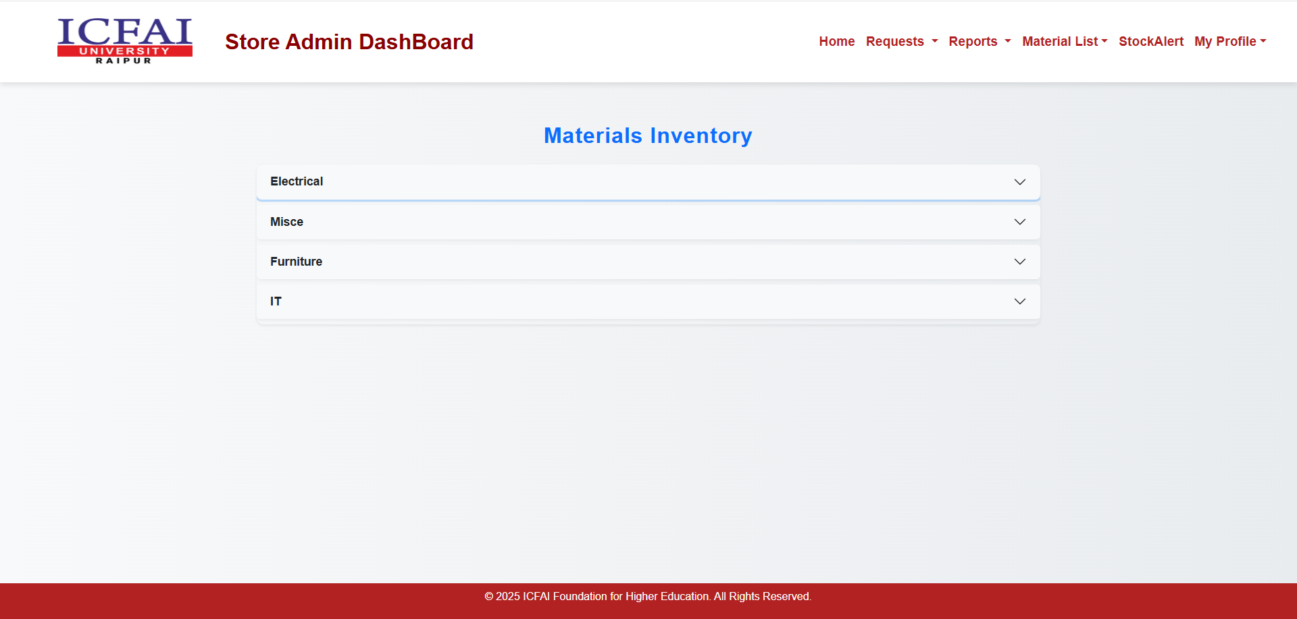

**Details Displayed:**

* Material Name
* Category / Subcategory
* Total Quantity
* Available Stock
* Issued Quantity
* Expiry or Warranty Details

**Functions:**

* Add new materials or update existing ones.
* Search and filter by asset type or category.
* Helps in quick decision-making for issuing or reordering stock.

### **8. Expired List**

This section automatically lists **materials that have expired, reached end of life, or been disposed of.**

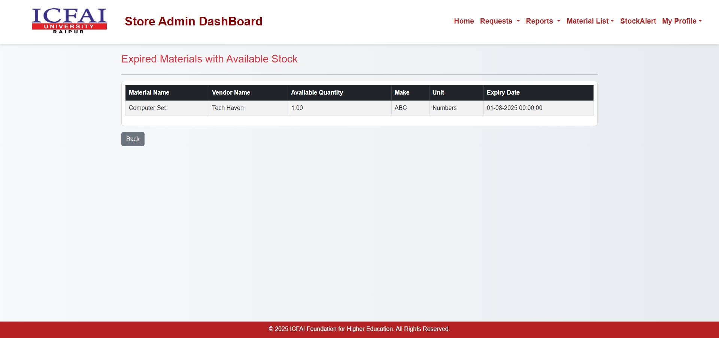

**Features:**

* Displays expiry date, disposal date, and material details.
* Option to mark assets as scrapped or replaced.
* Helps maintain an up-to-date inventory by removing inactive assets.

**Tip:** Review this list periodically to plan replacements or maintenance budgets.

### **9. Stock Alert**

The **Stock Alert** feature helps the Store Admin stay proactive about inventory shortages.

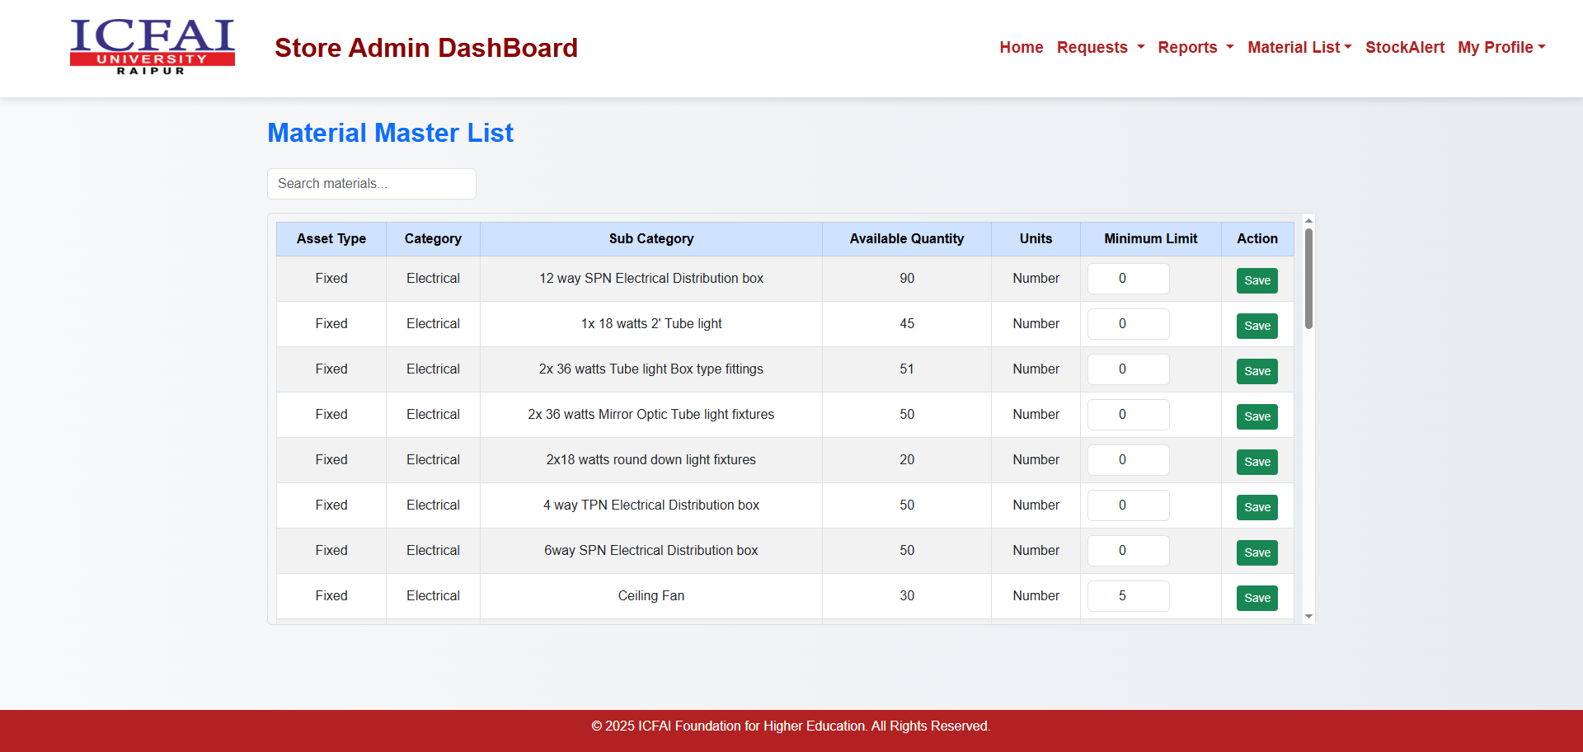

**Key Functions:**

* Automatically detects and displays materials **below the defined stock limit**.
* Sends alerts or notifications to the Store Admin and Local Purchase Department.
* Supports restock planning to prevent workflow delays.

**Benefits:**

* Prevents stock outs by maintaining optimal inventory levels.
* Enhances communication between Store and Purchase departments.

## ****4.4 Local Purchase Department Dashboard****

The **Local Purchase Department** is responsible for managing locally sourced materials, vendor coordination, and purchase order generation. This dashboard provides tools to view materials, handle procurement, maintain vendor information, and track departmental requests.

### **4.4.1 Materials List**

**Purpose:**  
Displays all materials available for procurement along with key details such as material name, category, sub-category, and current stock level.

**Features:**

1. View a list of materials available in the inventory.
2. Search and filter materials by name or category.
3. Check available stock and reorder levels.
4. Click the **“Add”** button beside any material to initiate a new procurement request.
5. The material added will be reflected automatically in the “Procurement” view for further processing.

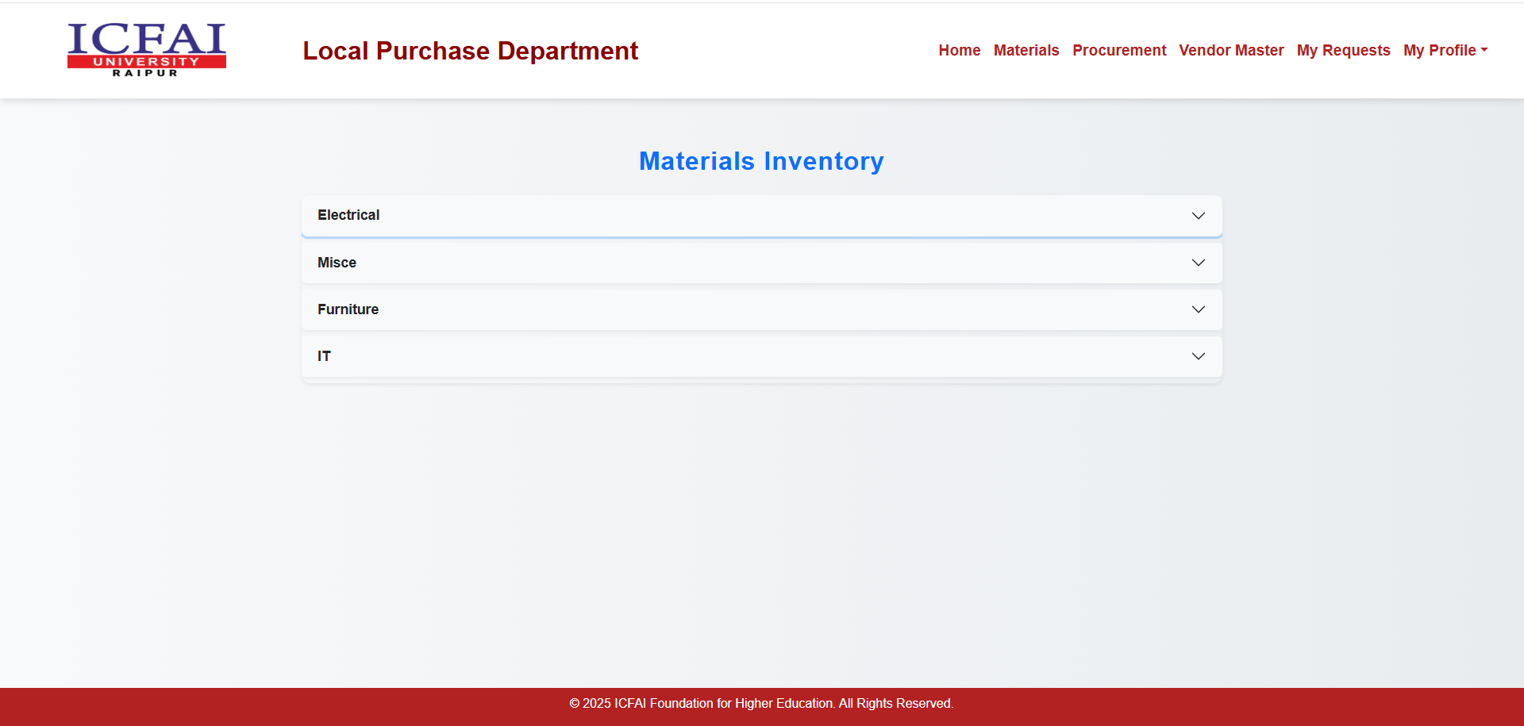

### **4.4.2 Procurement**

**Purpose:**  
Facilitates managing purchase requests, selecting vendors, and generating Purchase Orders (POs) for approved items.

**Features:**

1. Displays all procurement requests raised from the “Materials List” view.
2. Each row includes **Material Name**, **Order Quantity**, and **Request Type**.
3. Choose between **Local** or **Central** procurement type from the dropdown.
4. If **Local** is selected:
   * A **“View Vendors”** button appears to select a suitable vendor.
   * Upon vendor selection, details like **Vendor ID**, **Email**, **Price per Quantity**, and **Total Cost** are displayed.
5. The system automatically calculates **Total Cost = Quantity × Price per Quantity**.
6. The total amount is displayed on the top-right corner for easy tracking.
7. After verification, click **“Generate PO”** to create and send the Purchase Order to the vendor.

### 

### **4.4.3 Vendor Master**

**Purpose:**  
To manage vendor information and their associated materials efficiently.

**Features:**

1. Add new vendors along with their contact details and assigned materials.
2. Each vendor can supply multiple materials.
3. Materials are selected through cascading dropdowns:
   * **Asset Type → Material Category → Material Subcategory.**
4. For each material, enter applicable **GST Percentage** and pricing details.
5. Edit or delete vendor details as needed.
6. The Vendor Master ensures accurate and up-to-date supplier data for procurement.

### 

### **4.4.4 My Requests**

**Purpose:**  
Allows the Local Purchase Department to view and track all purchase requests raised and processed by the department.

**Features:**

1. View all past and ongoing purchase requests.
2. Each record includes **Request ID**, **Material Name**, **Vendor**, **Total Cost**, and **Status**.
3. Track request status — Pending, Approved, Rejected, or Completed.
4. Filter requests by date or vendor for quick access.
5. Export or print records for audit and reporting purposes.

## 

## ****4.5 Central Purchase Department Dashboard****

The **Central Purchase Department** manages procurement at the institutional level, ensuring standardized vendor selection and efficient material acquisition.

### **4.5.1 Received Requests**

**Purpose:**  
Displays all purchase requests received from departments or HODs for centralized procurement.

**Features:**

1. Lists all received requests with details like **University Name**, **Material Name**, **Quantity**, and **Requested Date**.
2. Clicking on a **University Name** expands or displays the list of requests from that university.
3. Each request can be viewed in detail before proceeding with vendor assignment or PO generation.
4. Enables centralized tracking of all department requests for efficient approval and procurement.

### 

### **4.5.2 Vendor Master**

**Purpose:**  
To maintain a centralized repository of approved vendors for institutional procurement.

**Features:**

1. Add and manage vendor information including **Vendor Name**, **Contact Details**, and **Materials Supplied**.
2. Assign materials through cascading dropdowns — **Asset Type → Material Category → Material Subcategory**.
3. Enter vendor-specific details like **GST%**, **Price per Quantity**, and **Email ID**.
4. Edit or remove vendors as necessary to keep data accurate.
5. Used during PO generation for automatic vendor data fetching.

### 

### **4.5.3 My Requests**

**Purpose:**  
Allows Central Purchase Department users to monitor and manage all procurement requests processed by them.

**Features:**

1. Displays a complete list of purchase requests raised or handled by the department.
2. Includes details such as **Request ID**, **Vendor**, **Total Cost**, **PO Number**, and **Status**.
3. Filter or search requests based on date, vendor, or PO number.
4. Track the full life cycle of procurement requests from creation to closure.

## 

## ****4.6 Local Accountant Dashboard****

The **Local Accountant** oversees financial activities related to local procurement and departmental expenditures.

### **4.6.1 Local Purchased**

**Purpose:**  
Used to record and verify payment details for locally procured materials.

**Features:**

1. Displays all approved local purchase orders along with vendor details and total cost.
2. Allows the accountant to mark payments as Pending, Paid, or Verified.
3. Upload payment receipts or transaction documents for record-keeping.
4. Helps ensure transparency in local purchase payments.

### 

### **4.6.2 Central Purchased**

**Purpose:**  
Tracks financial records of central purchase orders handled at the departmental level.

**Features:**

1. Lists all central purchase POs for which financial entries are made.
2. Displays vendor name, PO number, total amount, and payment status.
3. Ensures financial consistency between Local and Central accounting records.
4. Allows quick audit-ready data access.

### 

### **4.6.3 Budget Management**

**Purpose:**  
To manage departmental budgets and monitor expenditure against allocated limits.

**Features:**

1. Displays department-wise budget allocation.
2. Tracks total expenses versus available balance.
3. Helps prevent overspending by setting alerts when limits are approached.
4. Supports financial planning and transparency.

## 

## ****4.7 Central Accountant Dashboard****

The **Central Accountant** supervises overall financial management across the entire organization, ensuring all transactions align with institutional budget policies.

### **4.7.1 PO Details**

**Purpose:**  
Provides a centralized view of all Purchase Orders (POs) generated across departments.

**Features:**

1. Displays all POs with details like **PO Number**, **Vendor**, **Date**, **Amount**, and **Status**.
2. Allows updating payment status and remarks after verification.
3. Supports exporting PO data for audits or financial analysis.
4. Links directly to procurement and vendor records for traceability.

### 

### **4.7.2 Budget Management**

**Purpose:**  
To oversee and control the institution’s master budget allocation and spending.

**Features:**

1. Displays consolidated financial summary across all departments.
2. Provides monthly and yearly expenditure charts.
3. Allows adjustments in allocations based on performance or needs.
4. Ensures centralized visibility and accountability of funds.

## 

## ****4.8 Auditor Dashboard****

The **Auditor** has read-only access to verify and validate procurement, issue, and financial transactions for transparency and compliance.

### **4.8.1 View Requests**

**Purpose:**  
To audit and review all procurement and issuance records within the system.

**Features:**

1. Displays data grouped by **University Name**, **PO Number**, or **Request Type**.
2. Clicking on a PO reveals associated details such as:
   * **IUCD Approval Document**
   * **Purchase Order Details**
   * **Delivery Challan (Store Uploads)**
   * **Material Receipt Voucher (MRV)**
   * **Invoice Details**
3. Ensures complete traceability of the asset life cycle from request to delivery.
4. Facilitates transparency and audit readiness.

## 

## ****4.9 IUCD Dashboard****

The **Institutional User Committee Department (IUCD)** reviews and provides final approval for submitted purchase requests.

### **4.9.1 View Requests**

**Purpose:**  
To review and approve or reject purchase requests submitted by various departments.

**Features:**

1. Displays all pending and processed requests awaiting IUCD review.
2. Each record includes **Request ID**, **University Name**, **Vendor Details**, and **Status**.
3. The IUCD can open detailed request views and verify supporting documents.
4. Approvals are mandatory before final PO issuance.
5. Promotes accountability in institutional procurement decisions.

## 

## 4. Workflow

The Asset Management System follows a structured workflow ensuring transparency and accountability:  
1. Employee raises a material request.  
2. HOD reviews and approves or rejects the request.  
3. Approved requests are forwarded to the Store Admin for issue or to the Purchase Department for procurement.  
4. Local or Central Purchase Department handles procurement and vendor management.  
5. Accountants manage budgets and process payments.  
6. Auditors and IUCD review and validate processes for compliance and transparency.  
  
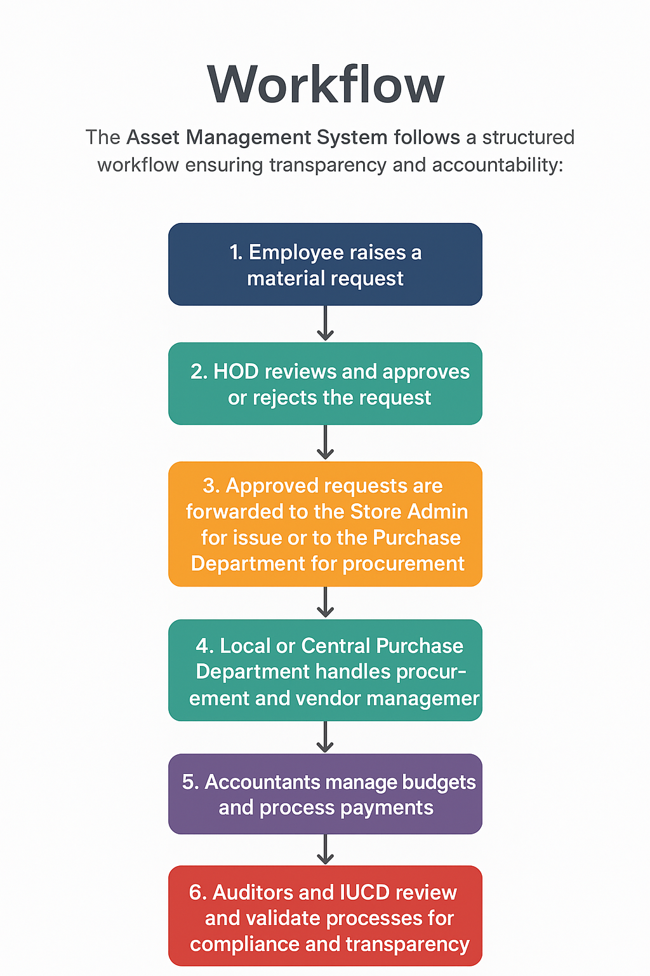

## 5. Troubleshooting & Help

Common issues such as login failures, missing requests, or approval errors can often be resolved by clearing browser cache or contacting the system administrator. Each department also has a designated support contact for system-related assistance.

## 6. Security & Access Control

The system enforces strict security protocols, including role-based authentication, encrypted passwords, and secure session handling. Each user’s access is restricted based on their assigned role, ensuring data integrity and confidentiality.

## 7. Future Enhancements

Potential future enhancements include:  
• Integration with RFID for automated tracking of assets.  
• Mobile application for easier access and real-time updates.  
• Automated email/SMS notifications for approvals and stock alerts.  
• AI-powered analytics for procurement and usage predictions.

## 8. Conclusion

The Asset Management System provides a comprehensive and transparent solution for managing institutional assets. By automating approvals, procurement, and inventory control, it ensures efficiency, accountability, and sustainability across departments.